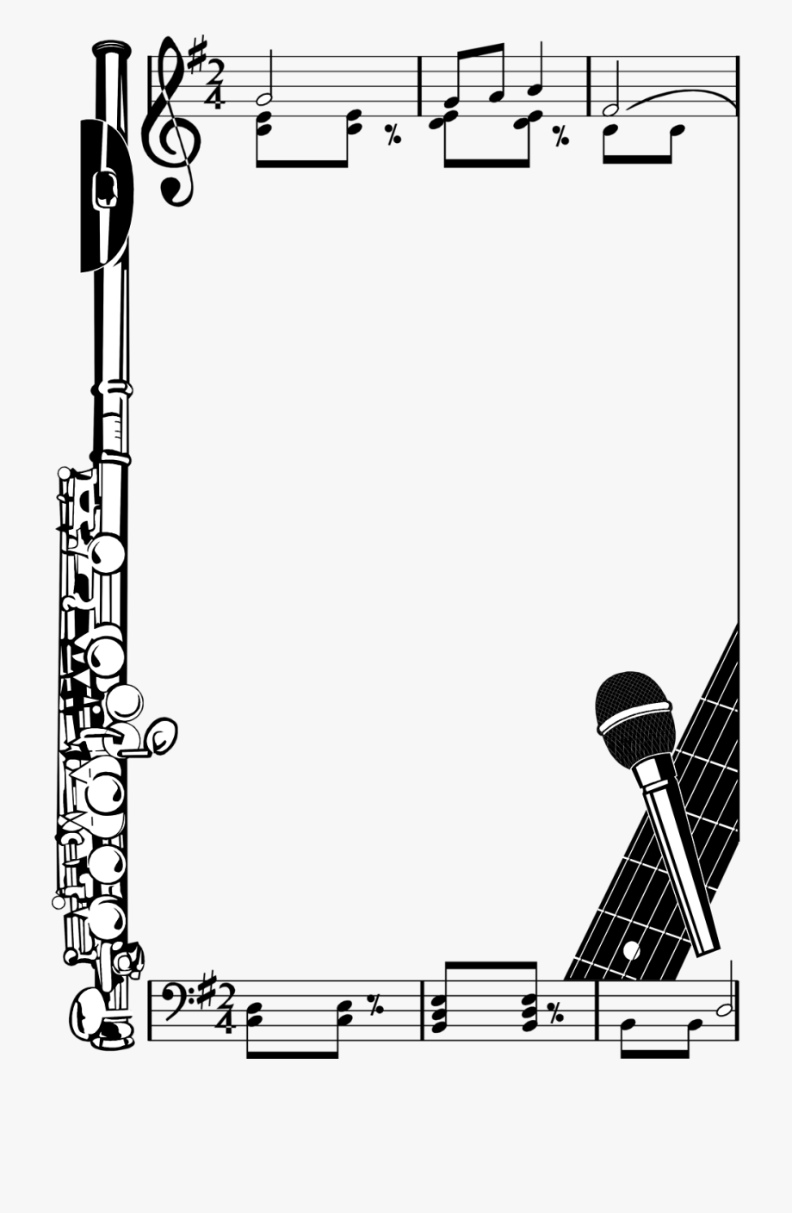

**Shull School Music**

**Marking Periods 2-3 Newsletter**

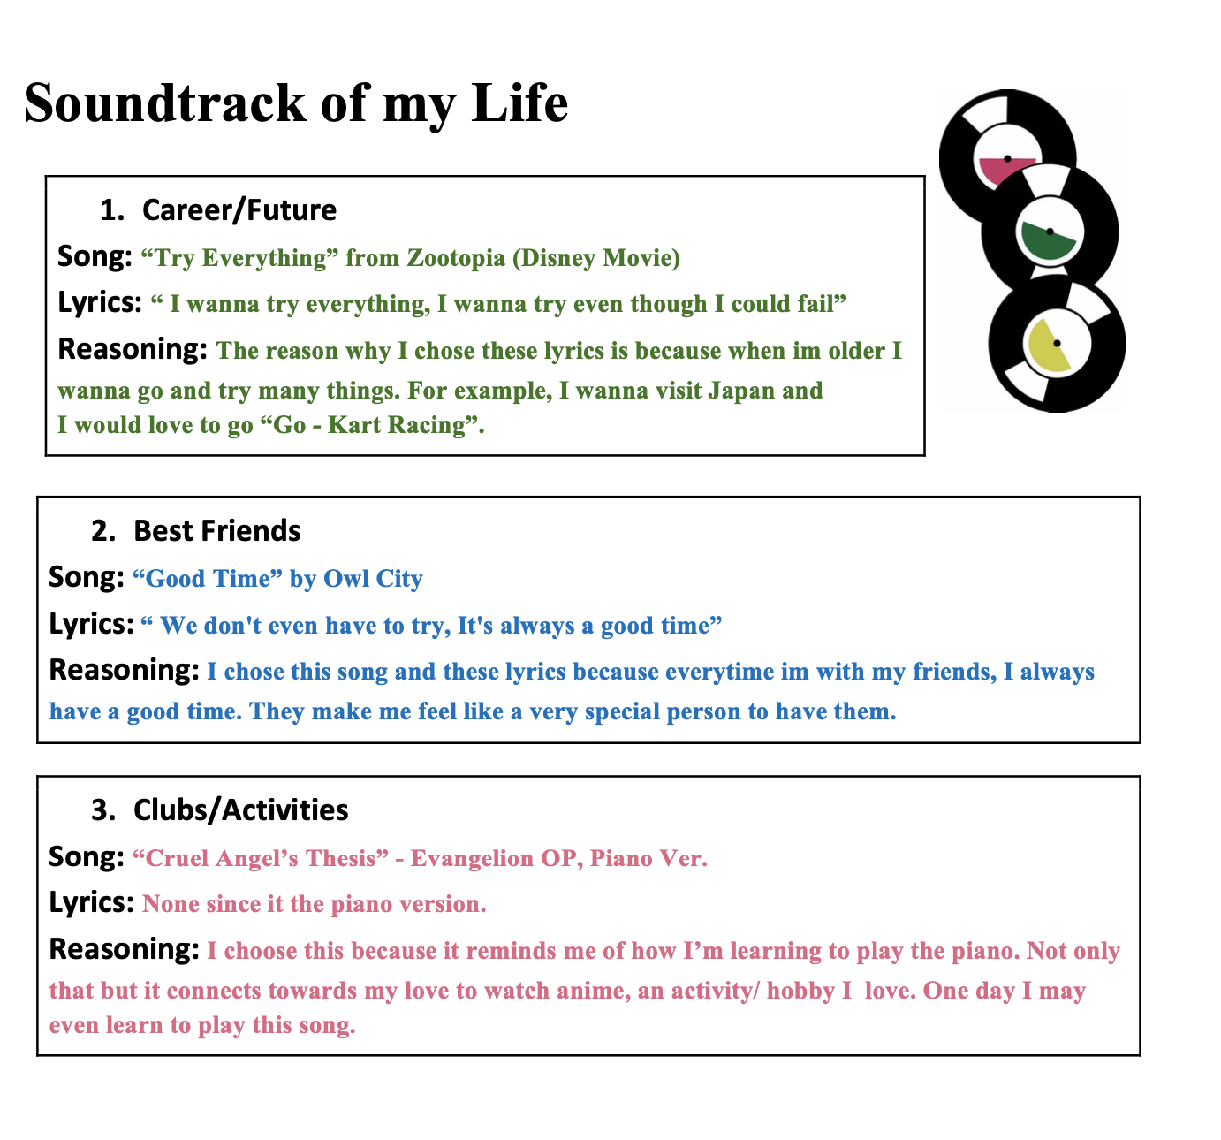

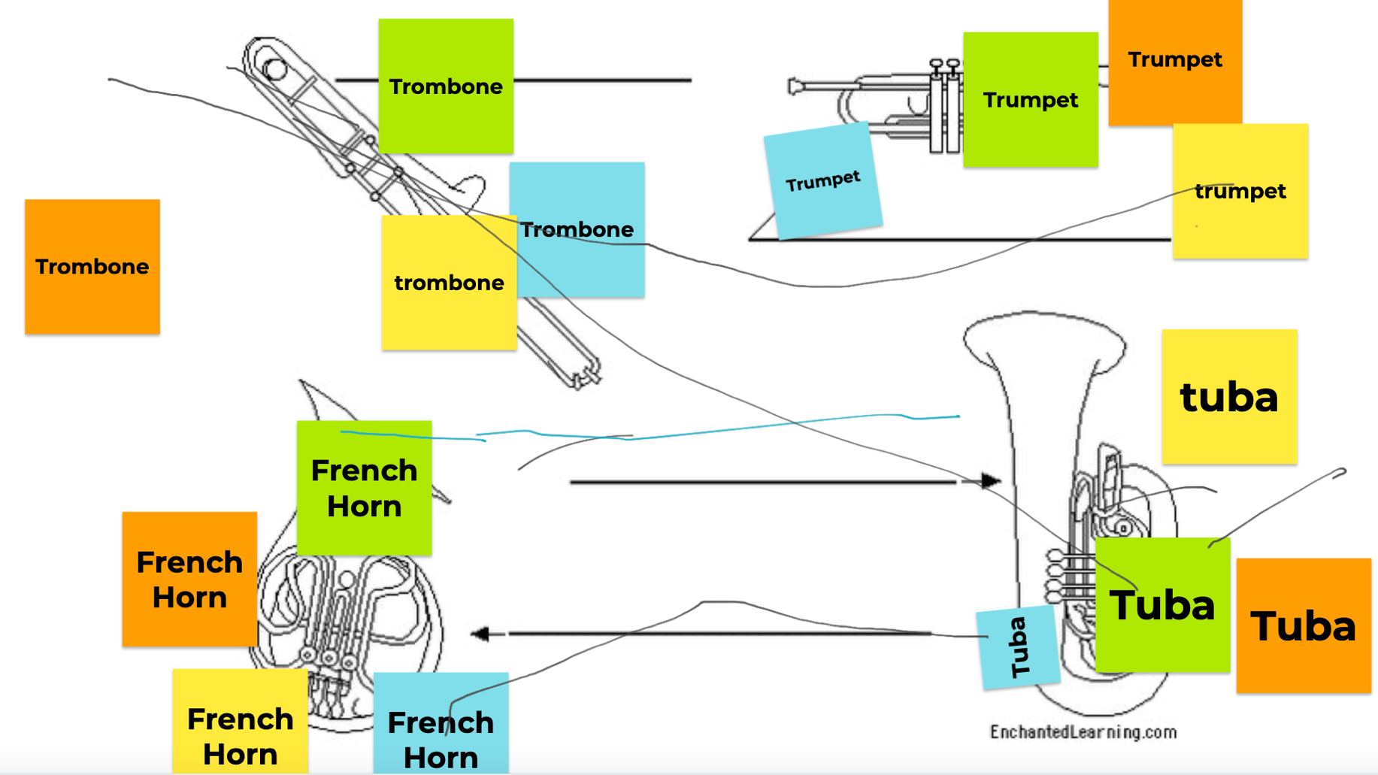

**Mrs. Bensulock’s Class Rocks!**

**Music with Ms. DeWitt**

